EAC397SYH: WEEK 4

Career Writing and Managing Your Digital Footprint Introduction to Workplace Correspondence

Agenda

1. Marcia Dunbar, Career Services Workshop
2. Creating scannable resumes
3. Cover letters: structure
4. Task: keywords in cover letters
5. Workplace correspondence: email

Resumes and Cover Letters

■ What is the purpose of the cover letter?

* + To persuade the hiring manager to look at the resume.

■ What is the purpose of the resume?

* + To persuade the hiring manager to grant an interview.

■ Viewed in 7-10 seconds by a person; less by software.

■ Use keywords in each document to illustrate how your qualifications fit the position.

Components: Chronological Resumes

|  |  |
| --- | --- |
| ■ Contact information  ■ Career objective*  ■ Profile summary  ■ Technical skills  ■ Education | ■ Other relevant sections: – Academic projects   * Volunteer positions * Certifications * Awards * References (on request)* |

■ Work experience

Scannable Resumes

■ Resumes that are formatted to be easily uploaded and scanned for keywords.

■ Use a basic, 10- to 12- (14-point for headers) font (e.g. Arial, Times New Roman).

■ Keep formatting simple:

* + Avoid borders, underlining, italics, columns, and graphics
  + Bold and bullet point lists are fine

■ Place your name, phone numbers, and email address on separate lines at the top.

■ If necessary, print the resume on plain paper using black ink.

Example: A Scannable Resume

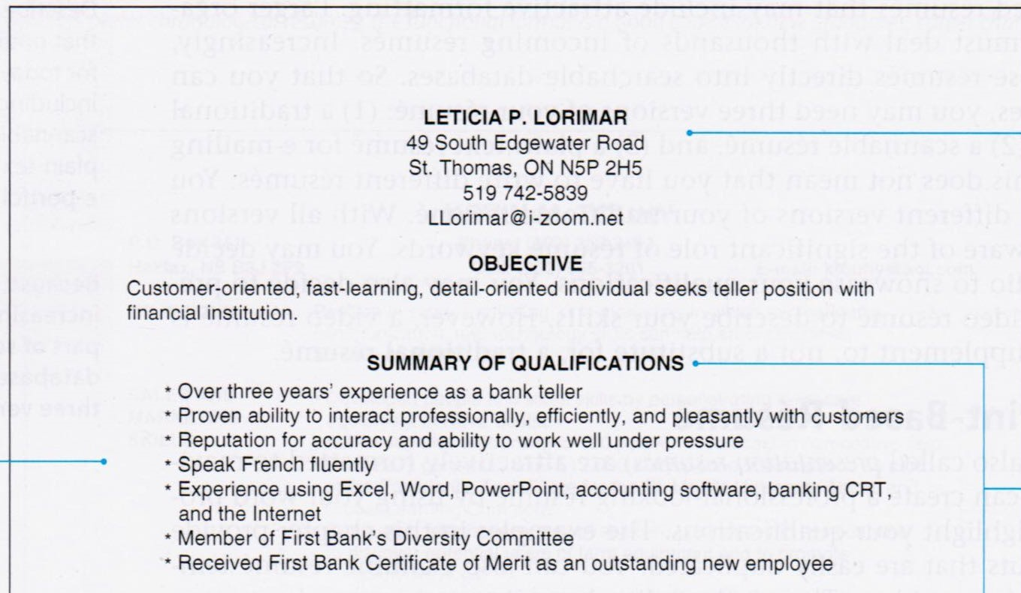

Name, phone number, and

email address appear on

separate lines.

Uses basic headings for easy

recognition.

Arial font

means

letters do

not run

into each

other.

Keywords from the job

ad appear throughout.

Using Keywords in Resumes

■ Build sentences around keywords and phrases.

■ [Action Word] + [Description] + [Result] = Accomplishment Statements

■ Remember to answer the “so what” question: Why is this accomplishment important? What value did this add?

■ Examples:

* + Encouraged customer service representatives to resolve telephone complaints in 7 minutes or less, reducing hold times by 25%.
  + Designed a library management system using C++ for IPC144 (Introduction to Programming at Seneca College) and received a grade of A+.

Transferable Skills

■ Skills that can be transferred from one position to another.

■ Examples:

* + Communication skills
  + Organizational skills
  + Leadership or management skills
  + Teamwork or interpersonal skills

■ Transferable skills can be found in:

* + Work experience in another country
  + Student work experience
  + Previous careers
  + Education and training
  + Volunteer positions
  + Sports and hobbies

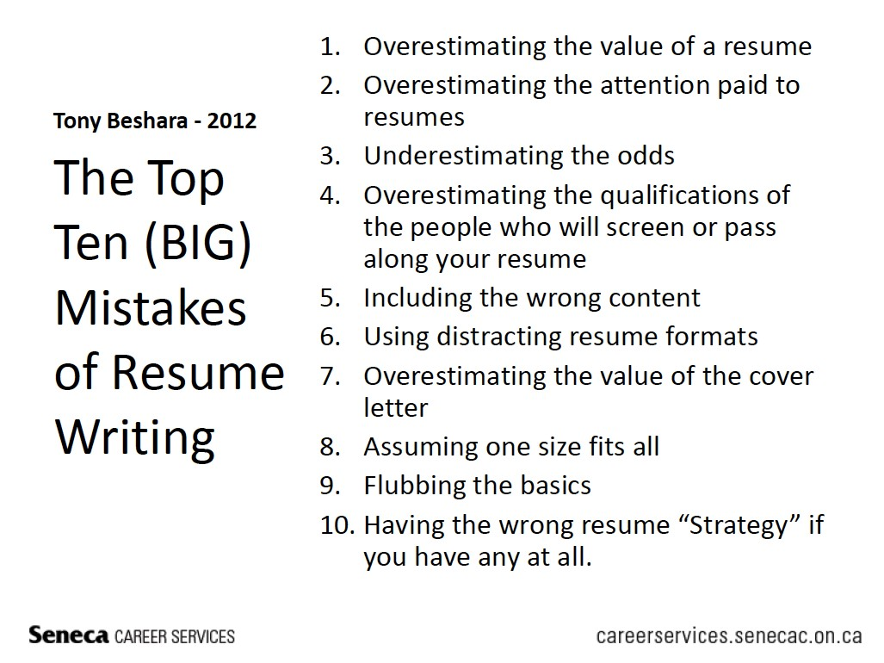

Sample Resume Critique

■ How much of this resume can you read in 10 seconds?

■ What do you like about this resume?

■ What could be changed or removed? Think about Marcia’s advice.

Writing Cover Letters

■ Use professional message structure:

* + Action opening [AO]
  + Background [B]
  + Details [D]
  + Action closing [AC]

■ Action opening: identify the purpose of your letter (application).

■ Background: match your experience and skills to keywords from the job ad.

■ Details: demonstrate knowledge of the company and why you are interested in it.

■ Action closing: identify next steps and how you can be contacted.

Example: Cover Letter (Body)

[AO] As a student at Seneca College, about to graduate with a diploma in Computer Systems Technology, I am applying for the Junior Developer position with SC Solutions advertised on Indeed.ca (job # 948274).

[B] In college I maintained a GPA of 4.0 while playing for Seneca’s women’s basketball team, the Seneca Sting. In keeping with my commitment to community service, this year I volunteered with the Toronto Red Door Women’s Shelter, where I developed a database to track fundraising projects. This database streamlined administrative tasks and allowed 2 staff members to devote 2 additional days a week to counselling clients.

[D] SC Solutions is a growing company that provides software solutions to the fundraising community. My experience along with my communication skills suit this position, and ensure that I would fit in well with your company’s socially-responsible corporate culture.

[AC] I look forward to the opportunity to discuss my qualifications in detail. I will be graduating in one month, and am available for an interview in the meantime. I can be reached at 555-555-5555 or by email at myemail@gmail.com.

Task: Cover Letters

■ Compose only the background paragraph (3-4 sentences) for a cover letter using the resume provided.

* Don’t just copy sentences from the resume!
* Use the resume’s underlined keywords to demonstrate the candidate’s qualifications in the cover letter.
* Create accomplishment statements: action word + description + result.
* Quantify wherever possible.
* Demonstrate enthusiasm, but use a formal tone.
* Use concise, clear language to create an effective and efficient message.

Workplace Correspondence: Email

■ Review the handout provided, which was published in 2012.

* Which of these points do already you follow?
* Have any of these practices changed/evolved since 2012?
* Is there any advice missing from this page?
* When should you not use email? That is, when are other forms of communication preferable?

Recommended Settings for Email

■ Use a professional email address and display name.

■ Settings: save a copy to “Sent mail” folder (purpose: to create a record).

■ Ensure your email is set to wrap text (so the reader does not need to scroll left to right).

■ Use an opening salutation: Hello XXX; Good afternoon XXX; Dear XXX

■ Use closing compliments and/or an email signature:

Best / Regards / Sincerely, Your Name

Your Name Your Job, Department

Your Contact Info

Composing Workplace Emails

■ Use an action-oriented subject line.

■ Begin with the four-part message structure, then adapt it to a direct or an indirect approach:

– Direct (good news): The purpose is stated at the beginning of the email. – Indirect (bad news): The purpose is stated at the end of the email.

■ Adapt paragraphing as appropriate for a formal/informal email.

■ Tip: the entire text of the email should appear on one screen.

Sample email message using workplace correspondence structure:

Date: September 27, 2017 08:55 am

To: EAC397 SYH students

From: katherine.ovens@senecacollege.ca

Subject: Due date for completing the Library Assignment

Hi everyone,

[AO] Please remember that your Library Assignment Series is due by 8:55 am on Monday, October 9. [B] As you know, this is an independent assignment that you can complete on Blackboard at any time. There are 4 learning modules and 5 quizzes in total. Most of the modules consist of video tutorials followed by a quiz. [D] Don’t forget that October 9 is a holiday and we will not have class that day. Even so, be sure to submit all 5 quizzes before the deadline. [AC] Email me if you have any questions.

Best,

Katherine

Next Week

■ Read Chapter 3 of *EAC397 Business Communications*.

■ If you plan to submit writing exercise 1, complete and submit it on Blackboard before class begins on Wednesday, October 4.

■ Keep working on your Library Assignment Series modules and quizzes, due before 8:55 am on October 11 (Thanksgiving).